Year 5 and Year 6 Spellings
To be tested on Thursday 1st February – -tial and -cial
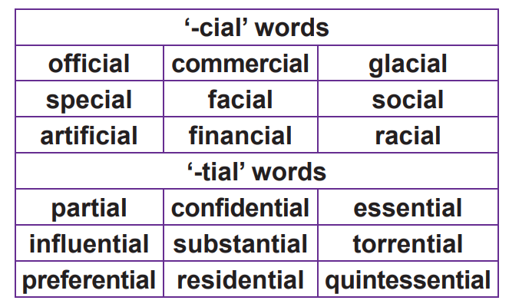
Year 5 and Year 6 Spellings
To be tested on Thursday 1st February – -tial and -cial
