Year 5 Spellings Week 2
The test on Thursday 21st September.
Silent letters

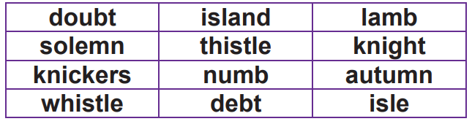

Year 5 Spellings Week 2
The test on Thursday 21st September.
Silent letters

