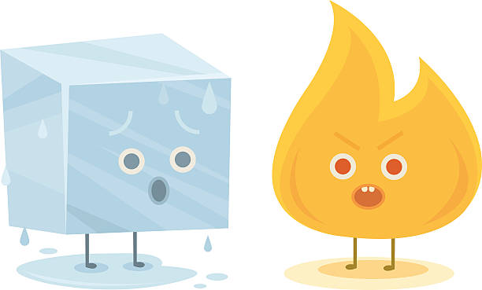

**PSHE: Money Matters –** Throughout this unit of learning, we will be exploring money. What money means, saving money, different payment methods and the difference between needing something and wanting something.

**Fire and Ice**

**Topic- Geography- Animals Homes Around the World**

This term, we are learning all about animals in different parts of the world. The children will learn about the 7 continents, hot and cold places, oceans and seas and the national animals of various countries.

**Music**

The children will be learning about the music of the British Isles and create music of their own. Children will learn about pitch, tempo and volume as well as composing pieces of music in a group.

**Art and Design and Technology**

Our focus this term is Art and Design, we will be exploring colour mixing and the difference between primary and secondary colours. We will also be looking at textures and a range of different painting tools. The Artist we will be looking at this term is Romare Bearden.

, and we will be exploring and making the structure of a babies chair. We will start by looking at the features and stability of the chair. Then, we will explore a range of materials and think carefully about what materials we could use to make our very own babies chair! The children will also be creating joints and structures with paper, card, and tape. Towards the end of term, the Puffins will be fixing and testing their very own chairs!

**Science- Homes and Habitats**

Our Science focus this term is living things and their habitats. The children will learn the difference between things that are living, dead and things that have never been alive. Children will learn what living things need to keep them healthy and alive. Children will be looking at habitats and how they are suited to each animal as well as food chains and different sources of food.

**PE** We will use the outdoor area on a Friday during independent learning time to promote outdoor learning and gross motor development. In PE this term children will learn a range of different ball games to promote hand-eye coordination, gross and fine motor skills and balance. At the end of term children will learn the rules and skills required in football. Please send your child to school in their PE kit on Fridays.

during independent learning time to promote gross motor development. The children will have one PE lesson on a Thursday. Please send your child to school in their PE kit on Thursdays.

**Computing**

This term in computing, the children will learn about programming robots and other forms of technology. Children will learn different commands and positional language (forwards, backwards, left, right) and use beebots to help understand commands.

about the importance of data and information. We will use a range of technology throughout our computing lessons. We will be counting and grouping objects digitally and compare the group of objects. Towards the end of term, we will be able to answer questions about a group of objects.

**Maths-**

This term the Year 1s will be consolidating their addition and subtraction knowledge with numbers to 20. We will then be looking at length and height with standard and non-standard measurements. Towards the end of term we will be looking at comparing and ordering numbers within 50.

The Year 2s will be learning multiplication and division. The children will be revising the 2, 5 and 10 times table. Children will learn to divide by 2, 5 and 10 and begin to understand odd and even numbers. Towards the end of term we will be looking at different charts and how we can input data using them. The last week of term the children will be revisiting shapes and looking at lines of symmetry, edges, corners and faces.

**RE** We will begin our unit this term by thinking about the religion Islam and finding out what they believe. We will think about the beliefs that Muslim people have and the importance of God. We will also look at the Qur’an, places of worship and the Prophet Muhammad.

**English**

**Phonics-** The Phonics Foxes and Ferrets (Year 1s and some Year 2s) will continue their daily phonics with Mrs Curtis and Mrs Dixon and the Phonics Fireflies (Year 2) will have their daily phonics sessions with Miss Mears. The children will be looking at adding suffixes to root words and how the suffix changes the meaning of the word.

**Grammar**- Year 1s will be continuing to punctuate sentences using full stops and capital letters and introduce exclamation marks into their sentences. They will also begin to extend their sentences by using the joining word ‘and’. Year 2 will continue to use adverbs, proper nouns and adjectives. They will learn how to write exclamation, command, statements and questions. As well as understanding how to use apostrophes (singular and possessive).

**Writing-** We will focus on sentence structure and formulating the best possible sentences. We will model correct grammar and new, ambitious vocabulary including words relevant to the topic and new words we have learnt in phonics. The children will able to add new vocabulary onto our word rainbow and use it in their own writing. The children will be rewriting stories and creating fact files for arctic animals, the children will use what they have learnt to form their sentences.

**Reading**- We will continue to develop the children’s comprehension skills during guided reading lessons and 1-1 reading. Your child will be sent home with a reading pack which will include books in their book band, a library book chosen by your child and their reading diary.