

It is important that your grant is used effectively and based on school need. The Education Inspection Framework (Ofsted 2019 p64) makes clear there will be a focus on ‘whether leaders and those responsible for governors all understand their respective roles and perform these in a way that enhances the effectiveness of the school’.

Under the Quality of Education criteria (p41) inspectors consider the extent to which schools can articulate their curriculum (INTENT), construct their curriculum (IMPLEMENTATION) and demonstrate the outcomes which result (IMPACT).

To assist schools with common transferable language this template has been developed to utilise the same three headings which should make your plans easily transferable between working documents.

Schools must use the funding to make additional and sustainable improvements to the quality of Physical Education, School Sport and Physical Activity (PESSPA) they offer. This means that you should use the Primary PE and sport premium to:

- Develop or add to the PESSPA activities that your school already offer
- Build capacity and capability within the school to ensure that improvements made now will benefit pupils joining the school in future years
- The Primary PE and sport premium should not be used to fund capital spend projects; the school’s budget should fund these.
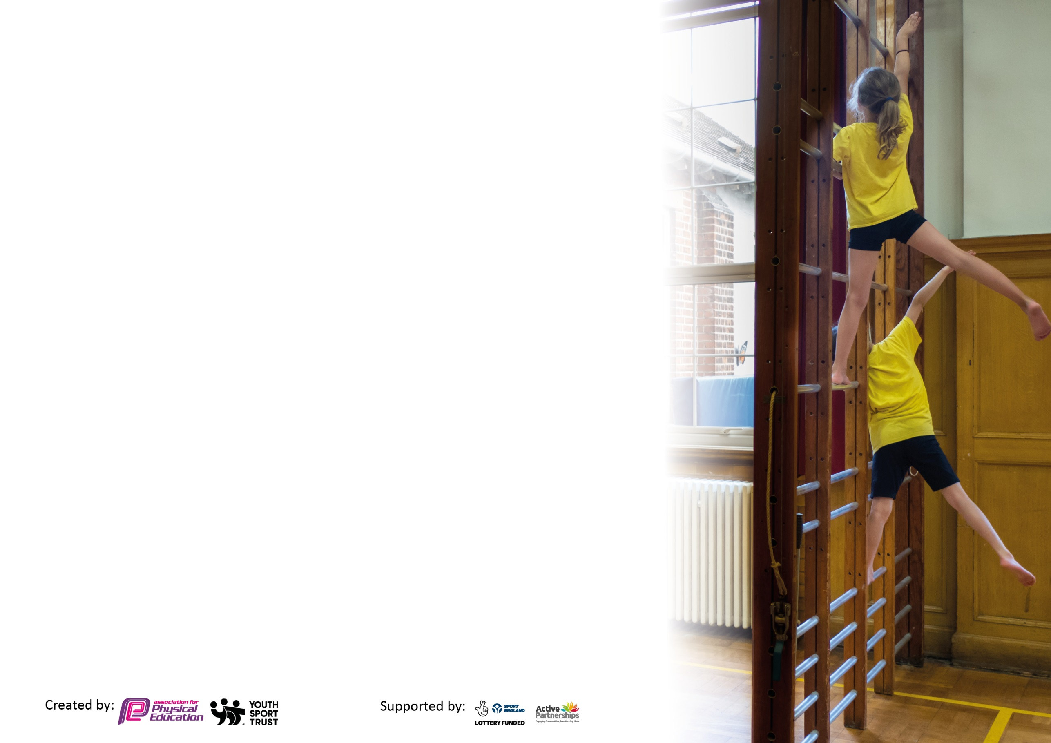
Please visit gov.uk for the revised DfE guidance including the 5 key indicators across which schools should demonstrate an improvement. This document will help you to review your provision and to report your spend. DfE encourages schools to use this template as an effective way of meeting the reporting requirements of the Primary PE and sport premium.

We recommend you start by reflecting on the impact of current provision and reviewing the previous spend.

Schools are required to publish details of how they spend this funding, including any under-spend from 2021/2022, as well as on the impact it has on pupils’ PE and sport participation and attainment by the end of the summer term or by 31st July 2023 at the latest.

We recommend regularly updating the table and publishing it on your website throughout the year. This evidences your ongoing self-evaluation of how you are using the funding to secure maximum, sustainable impact. Final copy must be posted on your website by the end of the academic year and no later than the 31st July 2023. To see an example of how to complete the table please click HERE.



Please note: Although there has been considerable disruption in 2020 it is important that you publish details on your website of how you spend the funding - this is a legal requirement.
Support for review and reflection - considering the 5 key indicators from DfE, what development needs are a priority for your setting and your pupils now and why? Use the space below to reflect on previous spend and key achievements and areas for development.

N.B. In this section you should refer to any adjustments you might have made due to Covid-19 and how these will influence further improvement.
Key achievements to date until July 2023: | Areas for further improvement and baseline evidence of need:
- School games Silver mark awarded.  - Increased participation in after-school clubs  - Pupils extremely active during break and lunchtimes.  - All pupils provided with the opportunity to access free fruit during break and lunchtimes.  - 100% of children have participated in PE and sport taking an active part in a wider range of opportunities in sport. | - Continue to offer inter-school competitions for all children, including pupil premium children. Affiliate with Amber Valley Sports in 23/24 to support inter school competitions.  - Establish more links with local sports clubs so children have easier access to physical activity outside of school.

Did you carry forward an underspend from 2021-22 academic year into the current academic year? NO * Delete as applicable
Total amount carried forward from 2021/2022 £0
+ Total amount for this academic year 2022/2023 £16,900
= Total to be spent by 31st July 2023 £16,900
Meeting national curriculum requirements for swimming and water safety.

N.B Complete this section to your best ability. For example you might have practised safe self-rescue techniques on dry land which you can transfer to the pool when school swimming restarts.
Due to exceptional circumstances priority should be given to ensuring that pupils can perform safe self rescue even
if they do not fully meet the first two requirements of the NC programme of study.
What percentage of your current Year 6 cohort swim competently, confidently and proficiently over a distance of at least 25 metres?  N.B. Even though your pupils may swim in another year please report on their attainment on leaving primary school at the end of the summer term 2022.  Please see note above. | 92%
What percentage of your current Year 6 cohort use a range of strokes effectively [for example, front crawl, backstroke and breaststroke]?  Please see note above. | 92%
What percentage of your current Year 6 cohort perform safe self-rescue in different water-based situations? | 92%
Schools can choose to use the Primary PE and sport premium to provide additional provision for swimming but this must be for activity over and above the national curriculum requirements. Have you used it in this way? | No

Action Plan and Budget Tracking
Capture your intended annual spend against the 5 key indicators. Clarify the success criteria and evidence of impact that you intend to measure to evaluate for pupils today and for the future.

Academic Year: 2022/23 | Total fund allocated: £16,900 | Date Updated: 24.07.23
Key indicator 1: The engagement of all pupils in regular physical activity – Chief Medical Officers guidelines recommend that primary school pupils undertake at least 30 minutes of physical activity a day in school |  |  |  | Percentage of total allocation:
 |  |  |  | 57%
Intent | Implementation |  | Impact
Your school focus should be clear what you want the pupils to know and be able to do and about  what they need to learn and to  consolidate through practice: | Make sure your actions to achieve are linked to your intentions: | Funding allocated: | Evidence of impact: what do pupils now know and what can they now do? What has changed?: | Sustainability and suggested next steps:
To improve outcomes, engagement and enthusiasm for all pupils during PE.  To motivate, inspire and engage all children in regular physical activity during break and lunchtimes. | KS1 PE lessons delivered by P.E Lead for 2 terms to support less experienced staff also participating in the lessons.  P.E Lead to take KS2 P.E lessons and support staff.  Sports Themed Event for whole school.  KS1 lunchtime sport clubs delivered by professional sports coaches from Active Ways.  Playground equipment to be purchased for the use at break and lunch times.  Appropriate storage for large equipment  Servicing Astroturf to keep it safe for all pupils. | £2600  £3,900  £500  £975  £500  £2000  £300 | Pupils have been engaged during these high-quality PE sessions and staff have been able to observe experienced teacher delivering PE sessions. More pupils have participated in extra-curricular activities due to their love of PE.  All pupils were involved and thoroughly enjoyed events and activities including Orienteering for Key stage 2 and Family Games afternoon of archery and fencing.  Pupils are always active during break/lunch times and enjoy the range of activities on offer. More pupils have participated in extra-curricular activities due to the nature of the engagement in break and lunchtime activities. E.G archery/dodgeball  PE equipment is stored and organised for easy access  Pupils able to continue to use the AstroTurf during break/lunch times and PE sessions. | Staff will be able to now use knowledge gained to deliver effective PE sessions next year.  Planning is sequential and progressive.  Engaging families in the themed day has been positive for the whole school community.  Continue to ensure break and lunch times are as enjoyable and active as possible by continuing to provide new equipment/activities etc.
Key indicator 2: The profile of PESSPA being raised across the school as a tool for whole school improvement |  |  |  | Percentage of total allocation:
 |  |  |  | 15%
Intent | Implementation |  | Impact
Your school focus should be clear what you want the pupils to know and be able to do and about  what they need to learn and to  consolidate through practice: | Make sure your actions to achieve are linked to your intentions: | Funding allocated: | Evidence of impact: what do pupils now know and what can they now do? What has changed?: | Sustainability and suggested next steps:
Ensure pupil’s physical and mental wellbeing continues to be of the upmost importance so pupils can achieve their full potential. | Fruit available for all children at break and lunchtimes.  KS1 and 2 physical activity (small-group interventions) for those who have struggled with resilience, independence and teamwork as a direct result of lockdown.  PE leader time to plan events such as the PE themed week/Sports Day  Training for P.E Lead EMET | £300  £1,623  Cover for P.E Lead £200 x 3 days | All pupils feeling hungry are able to access free fruit, which has had a positive impact on their learning.  Staff and coaches from Active Ways have noticed a difference in the resilience of the children in both PE and other lessons. Children have developed their teamwork skills and have grown in confidence.  A successful PE week planned and Sports Day that motivated and inspired the pupils and the school community. | Continue to purchase fruit for all pupils.  Using assessments from Active Ways and school staff, identify different pupils to engage in small group interventions for next academic year.

Key indicator 3: Increased confidence, knowledge and skills of all staff in teaching PE and sport |  |  |  | Percentage of total allocation:
 |  |  |  | 3%
Intent | Implementation |  | Impact
Your school focus should be clear | Make sure your actions to | Funding | Evidence of impact: what do | Sustainability and suggested
what you want the pupils to know | achieve are linked to your | allocated: | pupils now know and what | next steps:
and be able to do and about | intentions: |  | can they now do? What has
what they need to learn and to |  |  | changed?
consolidate through practice:
Increase confidence and knowledge of staff teaching PE. | Staff training for P.E Lead re-planning and assessment EMET  Staff meeting for students and inexperienced staff delivered by PE co-ordinator. | Cover x 3  £600  Free | PE lessons more structured as a result and decreases the amount of time spent on planning and preparing PE lessons.  Planning is in place and is progressive and sequential.  Students and staff observed leading P.E lessons shows improvements.  Pupil interviews are positive. | Ensure all staff in Sept 2023 are comfortable in teaching PE and repeat staff meetings/CPD where appropriate.  Continue to join EMET network for PE and develop subject leadership of PE  Affiliate with Amber Valley Sports next year 23/24
Key indicator 4: Broader experience of a range of sports and activities offered to all pupils |  |  |  | Percentage of total allocation:
 |  |  |  | 23%
Intent | Implementation |  | Impact
Your school focus should be clear | Make sure your actions to | Funding | Evidence of impact: what do | Sustainability and suggested
what you want the pupils to know | achieve are linked to your | allocated: | pupils now know and what | next steps:
and be able to do and about | intentions: |  | can they now do? What has
what they need to learn and to |  |  | changed?:
consolidate through practice:
Pupils to experience a broader range of activities and teamwork exercises.  Sports coach to provide after school clubs for all age groups to increase extra-curricular participation. | Sports coaches from Active Ways to provide multi-sports sessions to children across all age groups within the school. These sessions included dodgeball, invasion games, archery, tennis, cheerleading and dance. Sessions took place after school on a Monday-Thursday every week this year. | £2,550. | Nearly 80% of our children have engaged in the after-school clubs. There have been examples of pupils then attending clubs outside of school including dance, football and cheerleading. | Plan with Active Ways for after-school clubs for next academic year to ensure pupils continue to have the opportunity to access a wide variety of extra-curricular activities.
To provide experience of outdoor adventure activities for pupils in key stage 2. | To provide financial support and additional staff to support residential trip to Lea Green Educational Centre | £1400 | Activities were provided for the children to do things that they had not tried before. This was reflected in their resilience and participation in all activities.

Key indicator 5: Increased participation in competitive sport |  |  |  | Percentage of total allocation:
 |  |  |  | 2%
Intent | Implementation |  | Impact
Your school focus should be clear | Make sure your actions to | Funding | Evidence of impact: what do | Sustainability and suggested
what you want the pupils to know | achieve are linked to your | allocated: | pupils now know and what | next steps:
and be able to do and about | intentions: |  | can they now do? What has
what they need to learn and to |  |  | changed?:
consolidate through practice:
Improve opportunities for competitive activities – Inter and intra school competition | Improved exposure to winning and losing through competition entry. | £400 | Children have developed and understand the importance and etiquette within competition.  Children have demonstrated resilience when tackling difficult situations or not coming first. | Organise teams to take part in a wider variety of competitive sport next year

Signed off by
Head Teacher: | Natasha Austin-Cooke
Date: | 15th May 2023
Subject Leader: | Natasha Austin-Cooke
Date: | 15th May 2023
Governor: | Laura Wood
Date: | 16th May 2023

