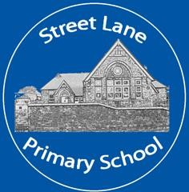
Street Lane Primary School Uniform Policy
2026

Contents
1. Aims 1
2. Our school’s legal duties under the Equality Act 2010 1
3. Limiting the cost of school uniform 2
4. Expectations for school uniform 2
5. Expectations for our school community 4
6. Monitoring arrangements 6
7. Links to other policies 6

1.Aims

This policy aims to:

- Set out our approach to requiring a uniform that is of reasonable cost and offers the best value for money for parents and carers
- Explain how we will avoid discrimination in line with our legal duties under the Equality Act 2010
- Clarify our expectations for school uniform

2. Our school’s legal duties under the Equality Act 2010

The Equality Act 2010 prohibits discrimination against an individual based on the protected characteristics, which include sex, race, religion or belief, and gender reassignment.

To avoid discrimination, our school will:
- Avoid listing uniform items based on sex, to give all pupils the opportunity to wear the uniform they feel most comfortable in or that most reflects their self-identified gender
- Make sure that our uniform costs the same for all pupils
- Allow all pupils to have long hair (though we reserve the right to ask for this to be tied back)
- Allow all pupils to style their hair in the way that is appropriate for school yet makes them feel most comfortable
- Allow pupils to request changes to swimwear for religious reasons
- Allow pupils to wear headscarves and other religious or cultural symbols
- Allow for adaptations to our policy on the grounds of equality by asking pupils or their parents to get in touch with the headteacher, who can answer questions about the policy and respond to any requests

3. Limiting the cost of school uniform
Our school has a duty to make sure that the uniform we require is affordable, in line with statutory guidance from the Department for Education on the cost of school uniform.
We understand that items with distinctive characteristics (such as branded items, or items that have a school logo or a unique fabric/colour/design) cannot be purchased from a wide range of retailers and that requiring many such items limits parents’ ability to ‘shop around’ for a low price.

We will make sure our uniform:
- Is available at a reasonable cost
- Provides the best value for money for parents/carers

We will do this by:
- Carefully considering whether any items with distinctive characteristics are necessary
- Allowing items without a school logo that can be purchased from most supermarkets
- Avoiding specific requirements for items pupils could wear on non-school days, such as coats, bags and shoes
- Avoiding different uniform requirements for different year groups
- Making sure that arrangements are in place for parents to acquire second-hand uniform items. We offer a preloved uniform selection at school. Please contact the school office for more information.
- Avoiding frequent changes to uniform specifications and minimising the financial impact on parents of any changes
- Consulting with parents and pupils on any proposed significant changes to the uniform policy and carefully considering any complaints about the policy

4. Expectations for school uniform

4.1 Our school’s uniform
We have a school uniform which consists of:
- White or red polo shirt or shirt

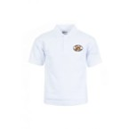
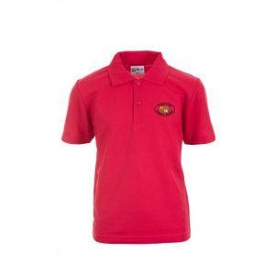

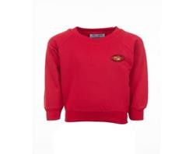
- Red sweatshirt or cardigan (with or without the school logo)
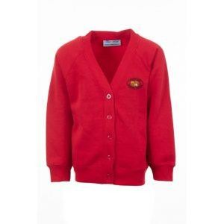

- Grey/Black trousers or school shorts (not sports shorts)
- Grey/Black skirt, pinafore or culottes (not sports shorts)
- Red checked summer dress
- Black shoes, boots, our trainers (without logos)
- Black, grey, red or white plain socks
- Black, grey or red plain tights

PE Kit for boys and girls consists of:
- Black shorts
- Plain red round necked t-shirt or red polo shirt
- Trainers
- Red hooded top and black bottoms can be worn for outdoor PE in cold weather (ideally black or a dark colour)
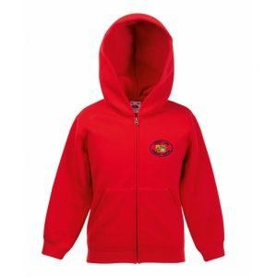
Children should wear their PE kit to school on PE days or if attending after school sport club.
Can you please ensure that all uniform, including shoes and trainers, are clearly marked with your child’s name to ensure that if any item is misplaced it can be returned to you.

Further Uniform Information:
- Children wearing lace up shoes need to practice fastening their shoes independently in KS2 is encouraged.
- Jewellery is limited to stud earrings only and these cannot be worn for PE or swimming. (The children must be able to remove and replace their own earrings independently).
- Please speak with the class teacher or Headteacher if you wish your child to wear any specific jewellery.
- Hair, which is of shoulder length or longer, should be tied back for school.
- Temporary skin tattoos and nail varnish are not part of school wear
- We expect all our children to wear suitable clothing for PE and outdoor activities.

4.2 Where to purchase it
Our official school uniform can be ordered from Loopwear. All orders can be made online by visiting Street Lane Primary School’s website and clicking on the link on the website. This can be found in the uniform tab.
Call: 01773 825865
Email: hello@loopwear.co.uk

Children can also wear supermarket purchased uniform that does not have the Street Lane Primary logo. This can be plain red/white polo shirts and red school jumpers and cardigans.

We also offer limited pre-loved uniform in the school office.

5. Expectations for our school community

5.1 Pupils

Pupils are expected to wear the correct uniform at all times (other than specified non-school uniform days) while:
- On the school premises
- Travelling to and from school
- At out-of-school events or on trips that are organised by the school, or where they are representing the school (if required)
- Pupils are also expected to contact the Headteacher if they want to request an amendment to the uniform policy in relation to their protected characteristics.

5.2 Parents and carers
Parents and carers are expected to make sure their child has the correct uniform and PE kit, and that every item is:
- Clean
- Clearly labelled with the child’s name
- In good condition

Parents are also expected to contact the headteacher if they want to request an amendment to the uniform policy in relation to:
- Their child’s protected characteristics
- The cost of the uniform

Parents are expected to lodge any complaints or objections relating to the school uniform in a timely and reasonable manner.

Disputes about the cost of the school uniform will be:
- Resolved locally
- Dealt with in accordance with our school’s complaints policy
The school will work closely with parents to arrive at a mutually acceptable outcome.

5.3 Staff

Staff will closely monitor pupils to make sure they are in correct uniform. They will give any pupils and families breaching the uniform policy the opportunity to comply but will follow up with the headteacher if the situation doesn’t improve.

In cases where it is suspected that financial hardship has resulted in a pupil not complying with this uniform policy, staff will take a mindful and considerate approach to resolving the situation.

5.4 Governors

The governing board will review this policy and make sure that it:
- Is appropriate for our school’s context
- Is implemented fairly across the school
- Offers a uniform that is appropriate, practical and safe for all pupils

The board will also make sure that the school’s uniform supplier arrangements give the highest priority to cost and value for money, for example by avoiding single supplier contracts and by re-tendering contracts at least every 5 years.

6. Monitoring arrangements
This policy will be reviewed every 2 years by the Senior Leadership Team. After every review, it will be approved by the full governing body.

7. Links to other policies
This policy is linked to our:
- Behaviour policy
- Equality information and objectives statement
- Anti-bullying policy
- Complaints policy

This policy is due to be reviewed by the Governing body in May 2027

