**Phonics-** We will continue teaching our Phase 2 Phonics programme and complete the first 18 single sounds. We will learn all of the phase 2 tricky words I, the, no, go, to and into. The children will continue to practise blending and progress to reading captions that include the tricky words they have learnt and the first 18 sounds. We will also teach the strong sounds ss, ll, zz, ff.

**Writing**-We will learn to formulate the letter shapes as we learn the sounds and complete lots of Funky Fingers activities to help with fine motor co-ordination.

**Reading-** We will have a focus book each week linked to our theme. It will be on the ECaT sheet along with suggested songs, rhymes and activities to share with your child. We will be reading some traditional tales and encouraging the children to sequence pictures to retell these familiar stories and to act them out using props and puppets. Our books include Stanley’s Stick, Elmer, Old Bear, Kipper’s Toybox and the ebook The Old Toy’s Room.

**Terrific Toys!**

**Physical Development** We will use the outdoor area every day during independent learning time to promote gross motor development. We will be having a Funky Fingers session every day and a session of Dough Disco and Wiggle While you Squiggle to encourage fine motor movements. The children will have PD activity time everyday where they will practise specific skills.

**PSED** The children have all settled well into school and are now very familiar with our routines. In week one we will have a fire safety focus with an exciting visit from firefighters and their fire engine! We will also have a weekly focus for Road Safety week and Anti-bullying week. Our constant theme for this term is exploring emotions which runs through all of these focus week activities. Towards the end of the term we will begin to prepare our children for our Christmas Performance of, ‘Boogie Woogie Nativity.’

**Maths** We will continue to practise counting forwards to 10 and introduce counting backwards from 10. We will complete lots of activities to find different representations of the numbers to 10 and complete subitizing activities to encourage the children to recognise the quantity of objects from the pattern they are arrange in. We will begin to compare the numbers to 10, saying numbers that are more and less and sequencing numbers.

**Shape, Space and Measure**

We will learn names of 2d shapes and words to describe them. We will continue and make our own repeating patterns.

**Shape, Space and Measure**

We will learn names of 2d shapes and words to describe them, discuss positional language and use language related to time in sequencing events during the day.

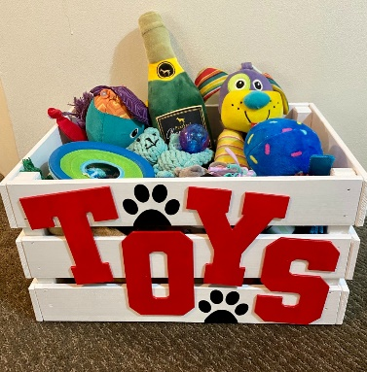

**Communication and Language** We will establish good routines for speaking and listening within the classroom and model correct grammar and new vocabulary. We will have a word of the week and display new vocabulary linked to our topic. The children will have a daily ECaT session where they can share and discuss work completed at home. We will use Makaton to support communication each day in the classroom. Towards Christmas we will have a Christmas Makaton sign each day.

**Understanding of the World**

We will be thinking about celebrations that we have and how we prepare for them and celebrate them at home.

We will discuss seasonal change and explore how the environment around them is changing through the season of Autumn in Winter. We will learn about animals that hibernate in the UK and animals that hibernate in Canada and North America. We will talk about toys that we enjoy playing with now and compare them to toys that parents and grandparents enjoyed when they were younger.

**Expressive Arts and Design**

We will encourage individual creativity during independent choosing time. This term our art-work will be closely linked to our weekly themes and topics.

We will practise using soft pastels to create fire work effect pictures, folding and cutting skills to create a Diwali paper lantern, collage and printing for wintery scenes and of course Christmas decorations, a calendar and Christmas cards.

**RE** We will be learning about how people celebrate within their own families. The children will talk about parties and experiences they have had and we will build up to discussing how people celebrate Christmas. We will also learn about how Hindu people celebrate Diwali and Jewish people celebrate Sukkot.